initialise binary occupancy grid map 1
initialise ROS communication 2
initialise map building with user input 2

initialise binary occupancy grid map
moro_map = load('moroparams.mat'); % load the provided .mat file
binary_map = moro_map.map; % extract the map
figure % create new figure
show(binary_map) % show the map
% get rows and cols used in the map
binary_map_rows = binary_map.GridSize(1);
binary_map_cols = binary_map.GridSize(2);
% create an zero matrix of dimension [(number of rows)*(number of cols),2]
vector_binary_map = zeros(binary_map_rows*binary_map_cols,2);
% fill the values of rows and cols into the zero matrix created above
counter = 1;
for iter1 = 1:binary_map_rows
for iter2 = 1:binary_map_cols
vector_binary_map(counter,1) = iter1;
vector_binary_map(counter,2) = iter2;
counter = counter + 1;
end
end
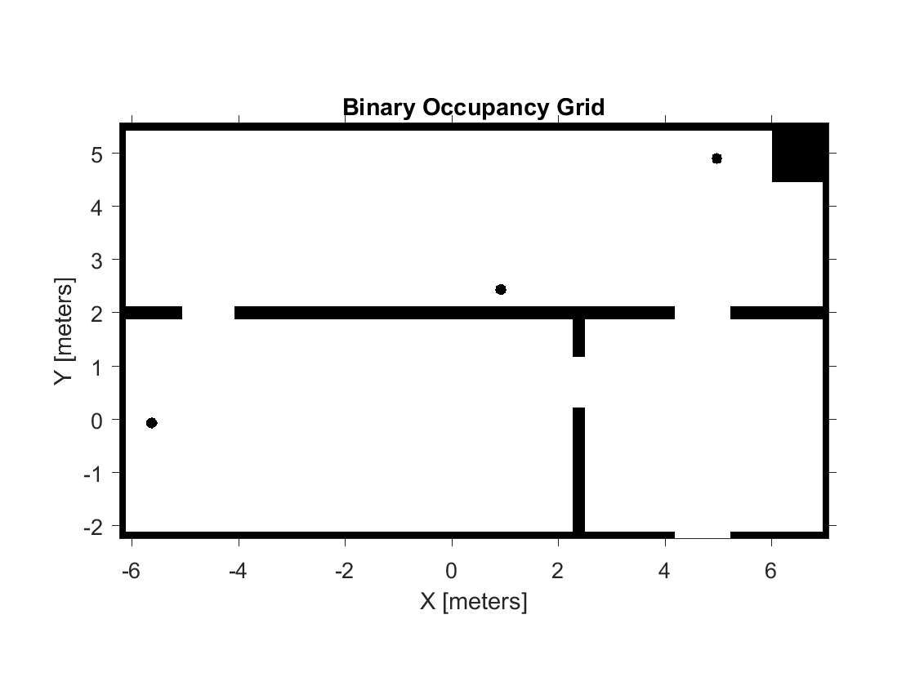

initialise ROS communication
for this program we are using 'odomCallback' and 'laserscanCallback'for receiving the position and laserscan measurement of the turtlebot
ex3_initializeRosCommunication
Error: File: E:\2nd year\Period 1-2\IHA-4306, Fundamentals of Mobile Robots\Exercise\Ex_3\Palash\Occupancy Grid Mapping\ex3_initializeRosCommunication.m Line: 3 Column: 8
Function definitions are not permitted in this context.
Error in ex3_bonus (line 24)
ex3_initializeRosCommunication

initialise map building with user input
create another map of the same dimension as the map provided but with binary occupancy set to 0 for all cells
setOccupancy(binary_map, vector_binary_map, 0, 'grid')
figure;
show(binary_map);
% initiate a infinite while loop asking for user input to proceed with map
% building.(press 1 to build map, press 0 to exit, other input will again
% ask for proper user input)
while 1
prompt = 'press 1 to proceed and 0 to exit';
user_input = input(prompt);
if user_input == 0
break
elseif user_input == 1
% if user input is 1 call function buildOccupancyMap with the
% current binary map.
binary_map = buildOccupancyMap(binary_map);
show(binary_map)
pause(1)
else
continue
end
end
Published with MATLAB® R2016a

